This is to be used for Year-Round Age Group, Varsity and Masters competitions.
This document has been created to help with preparing meet packages for sanctioning.
As per Swim Saskatchewan Board of Directors Policy C-4 Sanction applications must be uploaded no later than 5 weeks prior to the date of the competition.

Meet Managers are requested to use all 32 sections in this document when writing the meet package and to put them in this same order as this will help the Referees when reviewing and sanctioning our meet package and will help speed up this process. If things in this document are not included in your meet package, then your Referees r will return to you to add them.

An editable (word version of this document can be found on the Swim Sask website for easy use: How to Host — Swim Saskatchewan

IMPORTANT INFORMATION AND LINKS
The new rule book is constantly been updated, so ensure you are always going to the Rule book page of the Swimming Canada website, via the following link Rule Book and ensure that you use this link in meet packages going forward so that everyone is always using the most current version.

In addition, the facility rules, which supplement the rule book, were revised July 18, 2023, found at: Facility Rules

DQ’s – You may download from the Swim Sask website and print your own, or you may order them in a package from Swim Sask. The newest version of a DQ slip has reformatted Sept 8, 2022 in the bottom right-hand corner.

Number of Officials - The Master & Senior Officials Committee have indicated that the number of officials on deck must meet the minimum as outlined in the Rule book. All Clubs must strive to have a full complement of officials, as a full complement of officials ensures a fair and equitable competition for all swimmers. Contact your Meet referee to find out their expectations on staffing your competition.

REQUIRED: Send the final draft of your meet package to the 2nd Referee to review 2 to 3 weeks PRIOR to the date you want to upload to the Swimming Canada Meet List site for sanctioning. The List of Referees for each competition are posted here: How to Host — Swim Saskatchewan Please check regularly for updates.

REQUIRED: All sanction applications must be uploaded to the Swimming Canada Registration, Tracking and Results (RTR) online system. This is done with a Meet Manager login. If you do not have a Meet Manager login, then please contact your Club Registrar to set one up for you. RTR login access for Meet Manager

LINKS
- Swim Saskatchewan Website: Homepage

- Swim Saskatchewan Meet Hosting

- Swimming Canada RTR Login

- Events & Results – Swimming Canada

Please include the following logos in your meet package and meet program/heat sheets somewhere.
Link to these logo’s – Swim Sask and Sask Lotteries

Meet Package Information
Your meet package must include the following information/sections, and in some cases must include the actual statements given. Please use the following key to assist with writing your meet package:

KEY: Statements that must be included in your package are in bold black font

- Sanction #: (NOTE: the sanction number will be inserted by the Sanction Chair upon approval)

- Name of Meet, Dates of competition and name of club (s) hosting the meet and type of meet - Development, Invitational. Please see meet schedule.

- Session Times:
  - Provide time of Warm-up and Competition Start and End times for each day and session.
NOTE: Warm-ups need to end 10 minutes prior to competition start time to allow sufficient time for lane ropes to be tightened and electronics to be tested.
Clubs are encouraged to use their discretion for maintaining a single or split warm up based on the number of entries per session, particularly when younger and older swimmers are competing at the same session together.
  - Provide the time of the coach’s meeting if you intend on having one. A suggestion is to hold the coach’s meeting prior to warm-up so that coaches are not taken off deck during warm-ups. You may still host virtually the day or two before if you prefer doing that instead of in person on the first day of meet. Check with Meet Referee first.
  - Provide time of Officials Briefing. A suggestion is 30 minutes prior to the start of the competition.
  - You may also want to include a statement that says: Meet Management reserves the right to change session start times once entries are received. Coaches will be notified should the session start times change.
NOTE: to meet manager - Please see Appendix A on pages 9 to 11 for information on setting up sessions in Hytek Meet Manager to allow for additional time for backstroke ledges, clearing pool between heats and for adding a break during long course competitions for officials to walk to the other end for 50m events (if applicable). Please ensure you pass this information along to whomever is setting the meet up in Hytek Meet Manager.

- Location: Name of Facility, Address and Phone Number

- Facility:
  - # of Lanes that will be used.
NOTE: # of lanes being used could be different for prelims and finals,
Also, you don’t have to use all lanes of a pool (i.e., if a facility is 10 lanes you could state that the competition is only being held is 8 lanes).
  - Length of pool (advise if it is a 25 meter or 50-meter competition or a combination (25m prelims & 50m finals)).
  - Whether or not there will be any lanes available for Warm-up and Warm-down,
  - The type of timing system (i.e., Manual Watches, Dolphin system or full electronics).
  - Depth at Start end of the pool
  - Depth at Turn end of the pool
NOTE: If the turn end is only 1 meter deep or less, then you must also have the following statement in your meet package:
Swimmers must exercise caution when doing turns as the water is shallow.
  - NOTE: If the Turn end is 1 meter deep and you are offering 4 x 25-meter relays for a short course meet or 4 x 50 for a Long Course meet; then you must also have the following statement in your meet package:
There will be no diving at the turn end of the pool, 2nd and 4th place relay members must start in the water from a push.

- Meet Manager and Co Meet Manger if there is one
  - Make sure that each person is clearly identified as to who is the Meet Manager and who is the Co-Meet Manager if there is one. NOTE: there can only be 1 person listed as Meet Manager in the RTR when uploading for sanctioning.
  - Provide Name(s) and Contact Information

- Officials Coordinator - include all contact information.
- Officials
- Include information specifically for officials
  - Include how to sign up to officiate and deadline.
  - State if you will provide hospitality or not
- State if you are accepting officials from other areas or not. Suggest that you invite and encourage officials from all clubs to help officiate at your meet.
NOTE: Competitions are to run with a full deck of officials.

- Must include the following 3 statements in the document:
NOTE: (If you do a copy and paste of everything below, then the links should still work in your document)

- Swimming Canada Warm-up Competition Safety Procedures will be in effect at this competition. LINK

- Current Swimming Canada Rules will apply except as specifically modified in this meet package - Rules

- World Para Swimming Rules and Regulations will apply for Para swimmers – Rules

- Eligibility – you must include the following 4 statements:

- you must include statement “a” below, and perhaps also “b” and/or “c” statements if you intend on allowing master’s or summer swimmers.
- Entries will only be accepted for Year-Round Age Group Club swimmers, who are registered in the Swimming Canada registration database and have a Swimming Canada registration id number which is 9-digits, unless the swimmer is registered with and representing a foreign World Aquatics affiliated federation.
OR if a Masters meet then,
Entries will only be accepted for Masters swimmers, who are registered in the Swimming Canada registration database and have a Swimming Canada registration id number which is 9-digits, unless the swimmer is registered with and representing a foreign World Aquatics affiliated federation.
NOTE: For Year-Round age group meet, please also make a statement as to whether you will or will not allow master’s swimmers that are registered in the master’s Open category, (which means that they are registered the same as a 15 & Over age group swimmer) to compete in the meet in the age group events. Add one of the following statements:

- Entries will also be allowed for any master’s swimmers who are registered in the Masters-Open category.
OR
- Entries will not be allowed or any master’s swimmers who are registered in the Master-Open category.
NOTE: If your meet is during the period of May 1 to August 31, and you will allow Summer Swimmers who are registered in the Summer Open category, then add the following statement: Entries will also be allowed for any Summer swimmers who are registered in the Summer-Open category.

- You must include one of the statements below
For Age Group and Varsity Competitions use the following:
Swimmers must be a minimum of 7 years of age as of {insert date of first day of competition}
For Masters Only Competitions use the following:
Swimmers must be a minimum of 18 years of age as {insert date of first day of competition}
Age as of December 31, insert year the competition is being held, determines age groups for results.

- PARA swimmers who are registered with Swimming Canada or a World Aquatics affiliate are eligible to compete.

- Include a statement on whether the competition is only open to clubs in Sask, certain Sask clubs only, or if you are allowing clubs from other provinces to attend (Closed, Open, Open to Select Clubs Only (list clubs))

- Qualifying Times – state if qualifying times are required or not.
- If there are QTs required, must also state what time period they must be achieved in (i.e., all qualifying swims must have been achieved since Sept 1, 2020)
- You also need to state what qualifying times, if any, are required for Para Swimmers.

- Entry Deadline Date - Provide the date that entries must be uploaded to the Swimming Canada System by along with stating that they must be uploaded no later than 9:59 p.m.
The following 2 statements must be included:
All Attending coaches must be listed when uploading the entry file.
If a coach from the same club as the swimmers is not attending the meet, then you must inform the Meet Manager the name of the coach and club that will be responsible for coaching your swimmers.

- Entry Fees:
- Provide the cost for both individual and relay entries.
- Provide the name the cheques are to be made payable to
- Provide information on if fees can be paid via e-transfers or not and if so to what email address and any other specifics.
- State some wording about fees such as:
  - All entry fees must be received on the first day of the meet prior to warm-up.
  - No swimmer/team will be allowed to start warm-up until entry fees have been paid.

- Entries Refund Policy: Include the following statement:
- As per Winter Swimming Policy WC-4 found here

NOTE FOR MASTERS MEET MANAGER – Masters Meets do not have an Entries refund policy, therefore you do not need this section

- Entry Limit:
- Provide the maximum number of entries a swimmer may swim, and if it includes relays or not. This could be a max # per day or per meet maximum.
- State if there will be a limit to the maximum number of swimmers allowed into the meet, and what the number is.
If there is a max # of swimmers, then include a statement such as:
Entries will be accepted on a first-come, first-entered basis, by the date and time the Entry file is uploaded.
OR when the meet reaches xxx entered swimmers, then next team in its entirety will be accepted.
OR This meet will have a maximum number of xxx swimmers. To reserve your spot, contact (give name and email address of person to contact).
- Include a statement on whether the competition is only open to clubs in Sask, certain Sask clubs only, or if you are allowing clubs from other provinces to attend.
NOTE: Meet Management can choose to only allow Saskatchewan club swimmers, coaches, volunteers, and officials.

- Entries: Must include the following statement:
- All entries must be uploaded to the Swimming Canada Online Entries System. No entries will be accepted by email.
  - State whether Entry times are to be uploaded in SC or LC Meters and whether converted times will be accepted or not.
  - State whether No Time (NT’s) will be accepted or not.
  - List name and contact information for any questions about entries if they are to be directed to someone other than the Meet Manager.

- Relay Entries:
- State whether Relay entries may be submitted with or without names.
- If without names, then must also state when Relay names and/or name changes will be accepted until. (i.e., 30 minutes prior to the start of the session, after event # x).
- If Relays are being run in different age categories than the individual events, then list the relay age categories here.
- If Relays are mixed, then state if they must be 2 of each gender of if they can be comprised of any combination of gender. NOTE: Relays of any combination of gender become exhibition and not scored.
- Also state whether relay only swimmers are allowed or not. (For information only: this is when a swimmer has not qualified to enter the competition in individual events, but athlete just attends competition to be part of club relays.)
NOTE: Do NOT multi age relays. There have been lots of issues with this. Either run your relays with a separate event # for each age category or just as an Open Relay without multi aging. Make sure that whoever is setting up the Hytek Event File is aware of this.
NOTE: If Relays are being held as Open, then that means no age categories. An Open Relay means you could have a 7-year-old, an 11-year-old, a 15-year-old, and a 22-year-old all on the same relay.

- Deck Entries: Need to state whether Deck Entries will be allowed or not.
- If allowing Deck Entries, then also provide the cost.

- If you will allow, then suggest using the word “may”.
Suggested wording: Deck Entries may be allowed at the discretion of Meet Management and only if space permits; additional heats will not be created.

- If allowing Deck Entries, then also state for all events or if there are any exceptions. i.e., Deck entries are not allowed in the 800 and 1500 Free events. If there are no exceptions, then don’t need to say anything.

- If you are going to allow, then you need to include the following:
Deck entries are for additional swims for swimmers already entered in the competition and have passed registration validation, to swim additional swims in empty lanes. Deck Entries are not for day of competition entries.

- If allowing Deck Entries, then you need to include one of the following statements:
If a Heats and Finals competition:
Deck entries are “exhibition” and therefore will not be scored nor advance to finals.

If a Timed Finals competition:
Deck entries are “exhibition” and therefore will not be scored.”

- Meet Format/Competition
- Need to state if the events are being run as Timed Finals or Heats and Finals or mix of some events Timed Finals and some events Heats and Finals.
- If there are events with Heats and Finals, then need to also say whether just an “A” Final or if there are both “A” and “B” Finals.
- If both A and B Finals, then will there be a B Final regardless of number of entries or if will require a certain number of entries before offering the “B” Final.
- If offering both A and B Finals, then you also need to state which Final will be swum first. i.e., The “A” Final swims first followed by “B” Final.
- State if there will be a maximum number of entries for a specific event.
- State that Females and Males will compete separately.
- If you are not running separate Para events, and therefore Para swimmers are fully integrated into the meet, then you must include the following statement: There are no PARA-specific events or entry standards.
- If you are running a heats and finals competition, then state whether there will be separate Para Finals or not. If offering separate Para finals, then make sure that these are shown and well documented in the Event list. I.e., you might give Para Finals 300 series numbers

NOTE: Meet Managers – the following does not need to be put into your meet package, but you need to be aware that Para swimmers could be entered in an event but swim a shorter distance.

Example: entered in the 400 Free but will only swim 200 Free.
Their time for swimming the 200 will be approximately the same as the 400 Free
Coaches have been advised that they must speak to the Meet Manager and Meet Referee regarding this. This will involve you creating a new event the day of the meet to record these 200 Free results; same as you would if a coach asked for an official split.

- Seeding:
- State whether it is Senior Seeded or via age categories. If via age categories, then also need to state what the age categories are.
- State how the events will be seeded. I.e., slowest to fastest or fastest to slowest (the norm is slowest to fastest.)
- If not running separate Para events, then need to state: Para swimmers will be seeded according to their entry time.
- If your meet has distance events (800/1500 Free) state, how will they be seeded – slowest to fastest or fastest to slowest? (The norm for distance events has been fastest to slowest but slowest to fastest is acceptable). NOTE: This also needs to be set up correctly in Hytek
- State how you will be swimming the distance events. Alternating Female and Male is the norm.
- State whether the Distance events will be swum 2 swimmers per lane.
NOTE: As per Swimming Canada Facility Rules (revised July 18, 2023) rule 16.1.6 to swim 2 per lane, lanes should be at least 2.0 meters wide. Please ensure you measure your lane width prior to determining if running 2 per lane.
NOTE: you cannot swim 400 IM 2 per lane due to butterfly.

- Start
- One or more of the following must be inserted into your meet package.
NOTE: If Competition is double ended, then more than one of the below may need to be included to distinguish between ends. In addition, you may want to allow bulkhead and in-water starts.

    - Starts will be conducted from Starting Platforms (blocks) as per World Aquatics Rule II.16.1.4 and Swimming Canada Rules 4.1
and/or
    - Starts will be conducted from the Deck or Bulkhead as per Swimming Canada Rule C4.1.1
and/or
    - In-water starts will be conducted as per Swimming Canada Rule C4.1.2

- Scratch rule: You must put a scratch rule in your package.
- Make sure that it makes sense for the format of the meet.
  - i.e. if the format has both Heats and Finals as well as some events that are Timed Finals, make sure that the scratch rule covers all these types of events. It is recommended Meet Management consider penalties for No-Shows and late scratches for Finals.

- For a Timed Final meet, a suggested scratch rule is:
  - Scratches from preliminary heats simply create empty lanes, as there will be no re-seeding.
  - Scratches from heats may be made at any time without penalty except for loss of entry fee.
  - Clubs are requested to report any scratches no later than {insert time}

NOTE: There does not have to be a monetary penalty for not scratching. If you are going to quote a rule, make sure to read that rule and ensure that it makes sense for your type of meet.
- Scoring
For Club Invitationals, clubs are asked to consider not having any form of scoring, or offer any awards based on athlete rank or cumulative point score (i.e., medals, high point awards, etc.). Scoring and awards should be left to Championship competitions (i.e., Junior Provincials and ManSask) only.

- Awards
- Need to state if there are awards or not. If there are awards, what are they.
- Clubs are encouraged to offer bell heat prizes or draw prize opportunities for new personal bests or competing in a new event for the first time. Be creative and have fun.
- Clubs should not have medals as awards.

- Results
- Must state the age categories the results for both Individual and Relay events will be reported in.
NOTE: if you are running Mixed relays, then make sure you state what age categories the mixed relays will be
run in, as many times the ages for males and females are different, so make sure you indicated the relay age categories for Mixed Relays.
- Provide website URL link if you will be running Hy-Tek Live
- If results will be available on Meet Mobile, make sure to include the following statement: “Unofficial results will be available on Meet Mobile”
- Results may be printed and posted.
- Result file to be uploaded to Swimming Canada RTR within 24 hours of conclusion of meet. Best practice is to upload at the end of the competition.

For Masters only competitions must say: Results will be published in age groups as specified by Swimming Canada Masters Age Groups

NOTES: For Information only; do not put into meet package:

- reminder of rule C13.3.3 that states Officials splits will be reported as a separate event in the meet results. Make sure whomever is running the computer during the meet is aware of this. Suggest using 900 series event #’s for this. So for example if a split is being requested for Event #21 then the official split event number would be #921

- Instead of printing, consider being environmentally friendly and continue with covid best practice and have Heat sheets/meet programs posted online on Meet Mobile, or other mobile applications, or club websites.

- Host club needs to maintain a signed copy of official results as well as the Hytek Meet Manager Backup File for a minimum of one year.

- Official Splits
You must state the process for requesting Officials Splits in your meet package.
Suggested wording: Official split request must be submitted to Meet Management a minimum of XX minutes prior to the start of session or XX minutes prior to the start of the event.

- Meet Safety Rules
- Suggest stating if there will be a certain time during the warm-up, which lanes will be designated as diving lanes and if there will be pace lane(s) or not, and if so, what lanes those will be.
- You may want to include the following statement:
Depending on the number of Para Swimmers, and their sport classes, entered in the meet; there may be one lane during warm-ups for Para Swimmers only.

NOTE: if Para swimmers are attending your meet, then mats should be put at the side of pool at both outside lanes, where swimmers exit the water. There will need to be mats on both ends when a long course meet.

- General or Facility Information
- Responsibilities of swimmers or club etc.
- Food allowed on deck or not
- Check with facility prior to uploading meet package for sanctioning if they still have any Covid 19 related items.

- Other Meet Related Events
- Provide details related to events that are part of the sanctioned competition (banquet, concessions, T-shirt sales, penny parade, etc.)

- Community Information and Accommodations
- List If there are any hotel rooms blocked and provide relevant information; Even if no hotels have been blocked it is still nice to list nearby hotels.
- List any community info i.e.: discounts at stores or restaurants for event participants.

- Must include the following 3 statements in the document:
Heading: Photography/Videography
    - In order to minimize risk, all photographs and video taken at Swimming Canada/Swim Saskatchewan sanctioned competitions, whether taken by a professional photographer or videographer, spectator, team support staff or any other participant, must observe generally accepted standards of decency. Under no circumstances are cameras or other recording devices allowed in the area immediately behind the starting blocks during practice or competition starts, or in locker rooms, bathrooms, or any other dressing area.
    - For full details see the Event Photography and Videography Procedure Policy found HERE
    - Clubs may appoint one official photographer for their club to be granted access to a designated area/working deck. Please contact Meet Manager prior to the competition for permission.
    - Meet Management may issue an accreditation/name tag identifying such person.
If a tag is issued; then it must be worn at all times.
Heading: Safe Sport
    - Swimming Canada and Swim Saskatchewan believes that athletes, coaches, officials, support staff and volunteers have the right to participate in a safe and inclusive sport environment that is free of abuse, harassment, and discrimination.
Swimming Canada Safe Sport Policy found HERE and other Safe Sport Resources HERE.
    - Only participating swimmers, officials, registered coaches, and authorized people are allowed on deck.
    - Swim Saskatchewan and Swimming Canada have signed onto the Responsible Coaching Movement, which means that all interactions between an athlete and an individual who is in a position of trust should normally, and wherever possible, be in an environment that is both “open” and “observable” to others.

Heading: Swimwear
All swimmers are permitted to race with the swimwear of their choosing at all competitions sanctioned by Swim Saskatchewan. It is not required to declare the choice of swimwear to the Referee, if the fabric of the swim wear is a permeable open mesh textile and would not reasonable be seen to create a technical advantage in terms of speed, buoyancy, or endurance.

- Event Schedule/Order of Events
- Provide a list/table of the events, the age category (if applicable for each event) and the events numbers for both Female and Male events. NOTE: if running mixed relays then there is only 1 event # for that relay
- As Meet Manager you should work with your head coach to develop the list and order of events.
- Suggested (not required) events at Club Invitationals are: (25m at short course meets only)
  - Events for 7 & 8 yr. old - 25 and 50m events of all strokes, + 100m freestyle, backstroke, medley
  - 9 & 10 yr. old - 25, 50, and 100m events all strokes, + 200m freestyle, backstroke, medley
  - 11+ yr. old - 50, 100, 200m events all strokes, 400m freestyle & medley, + 800 & 1500 freestyle
  - Coaches of Paralympic athletes may work with host meet management about “time matching” Paralympic events within Olympic/Non-Olympic events (i.e., enter a Para swimmer in the 400 Free event, however the swimmer will only actually swim 200 Free. Their time for the 200 may be similar to 400 Free).

Appendix A

This is information for person setting up competition in Hytek Meet Manager. Meet Manager please ensure you pass this information along to whoever is setting up Hytek Meet Manager. This is information to help with session timelines.
1. For competitions using backstroke ledges, please add an additional 15 seconds (15 seconds default + 15 seconds ledge installation = 30 seconds total) between heats in the backstroke events to allow for the installation of the backstroke ledges. This is done in the 'sessions screen' of Hytek Meet Manager. Please refer to image #1 below for instructions on how to do this.
2. For sessions where the pool is cleared between heats (ie. in finals), please add an additional 15 seconds between heats to clear the pool. This is done in the 'sessions screen' in Hytek Meet Manager. The default interval is 45 seconds but suggest changing to 60 seconds for the heat in finals. Please refer to image #2 on next page for instructions on how to do this.

3. During long course competitions where officials need to move from one ed to the other for 50m events, please add a 3 minute break before and after the 50 meter events. Please refer to image #3 for instructions on how to do this.
Image #1

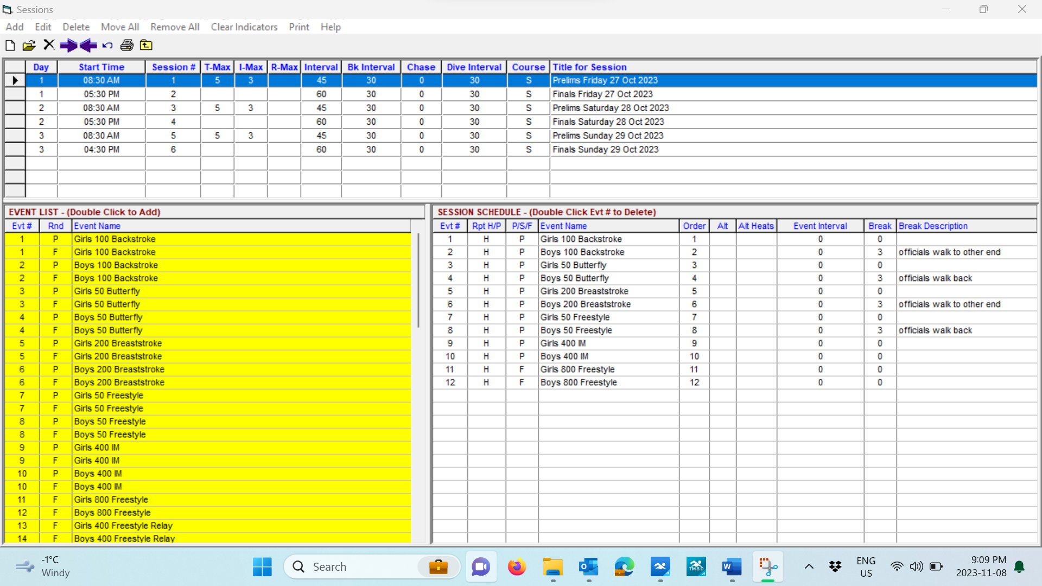

Image #2

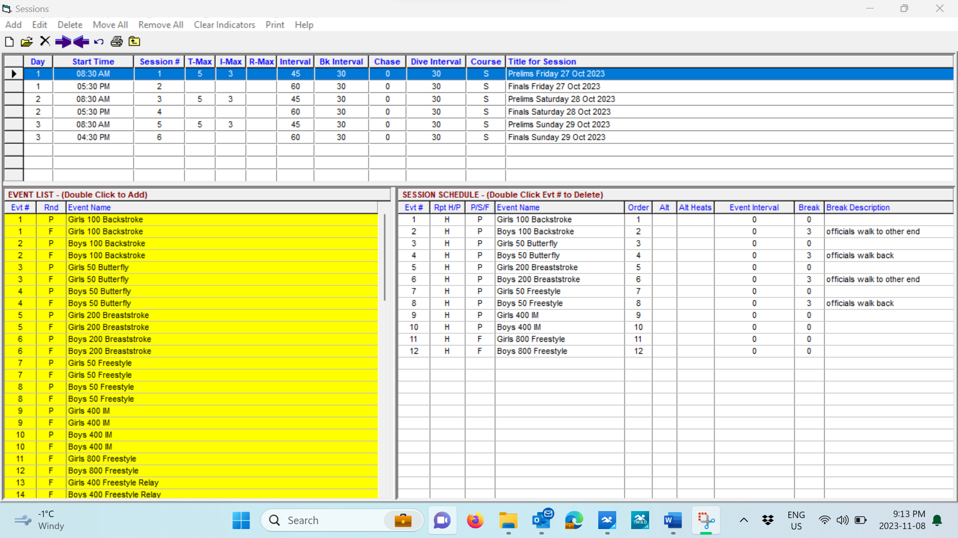

Image #3

